

**Placement Empowerment Program**

***Cloud Computing and DevOps Centre***

**DAY 11 TASK**

Use Cloud Storage Create a storage bucket on your cloud platform and upload/download files. Configure access permissions for the bucket.

Name: Shahana.M.S Department: ADS



‘

**Introduction**

Cloud storage is a scalable and secure way to store and manage data in the cloud. Cloud providers such as AWS, Azure, and Google Cloud Platform (GCP) offer storage buckets that allow users to store, retrieve, and manage files efficiently. By creating a storage bucket, users can upload and download files while configuring access permissions to ensure security and controlled data sharing.

**Objective**

* To create a storage bucket on a cloud platform (AWS S3, Azure Blob Storage, or GCP Cloud Storage).
* To upload and download files using cloud storage services.
* To configure access permissions for secure data management.
* To understand how cloud storage integrates with other cloud services.

**Importance**

* **Scalability**: Cloud storage can handle large amounts of data with automatic scaling.
* **Reliability**: Ensures high availability and redundancy for stored files.
* **Security**: Provides fine-grained access control using IAM policies.
* **Cost-Efficiency**: Pay only for the storage used, reducing infrastructure costs.

**STEP-BY-STEP OVERVIEW:**

Step 1: Go to AWS Management Console,Search S3 and then create a bucket,make sure your bucket name is unique.

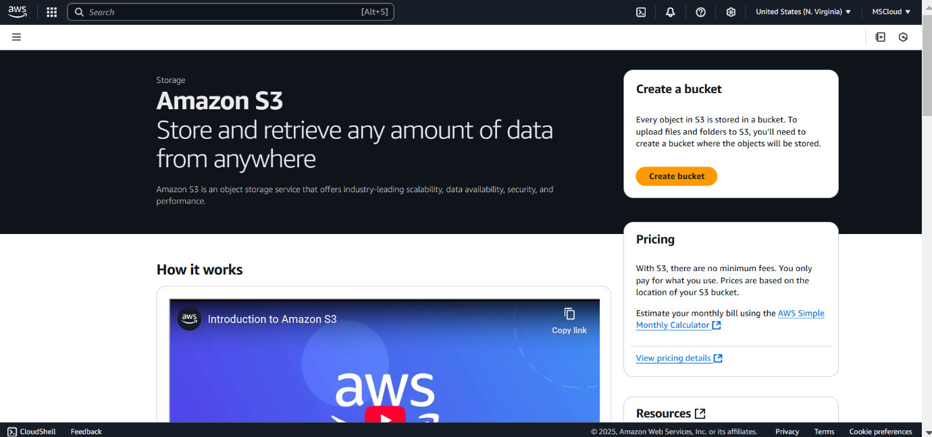

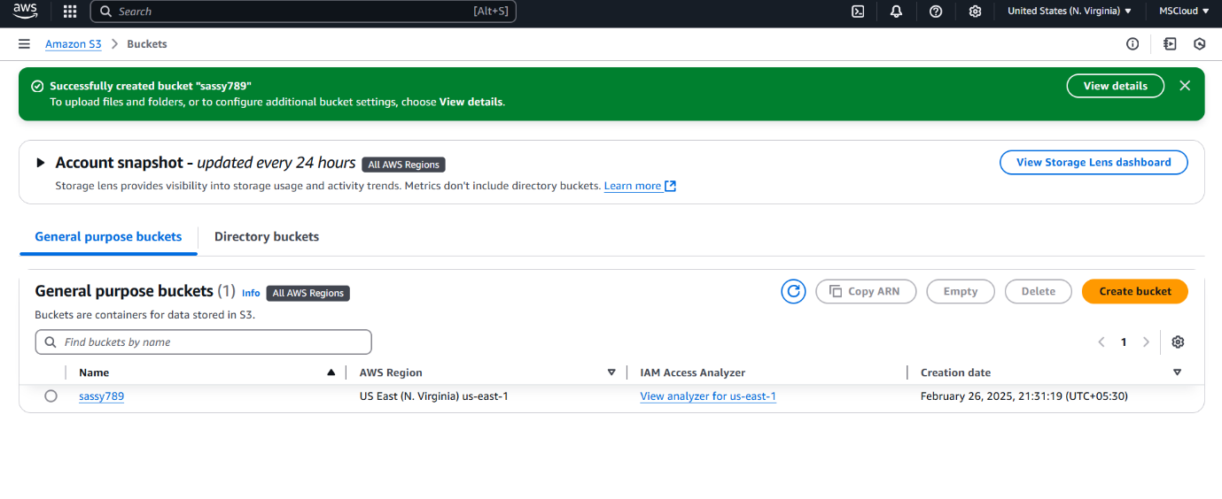

Step 2 : Now , click the file(blue part) and then go to the upload page where you upload anything you want and click upload below

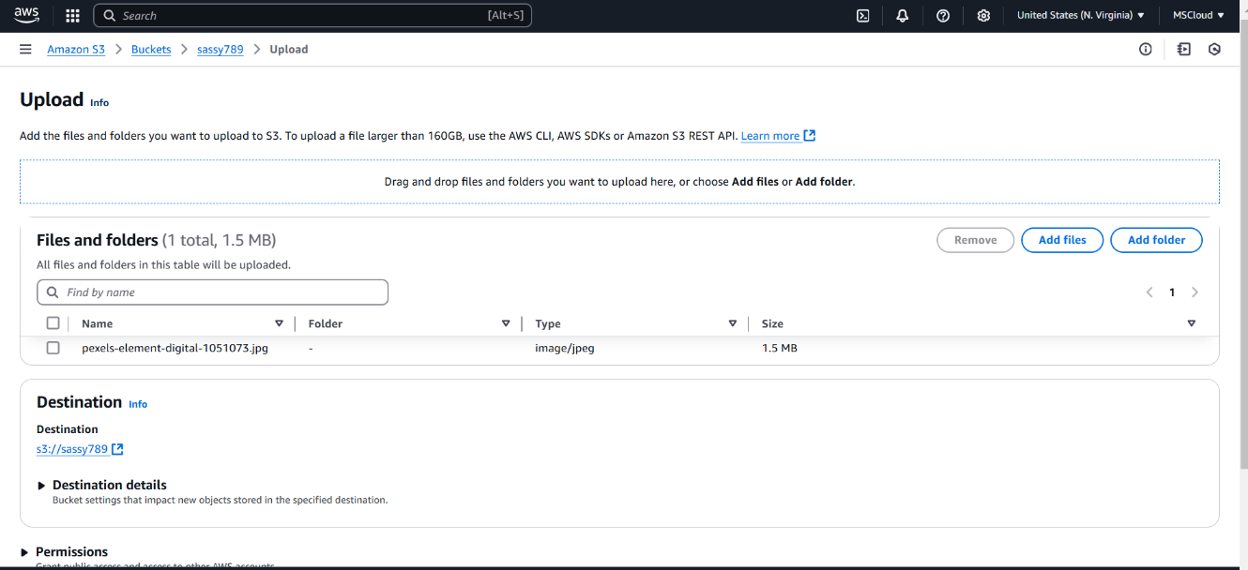

Step 3: simply in the permissions after uploading just enable public access and click save changes and make some changes in permissions where in the code don’t forget to type your bucket name

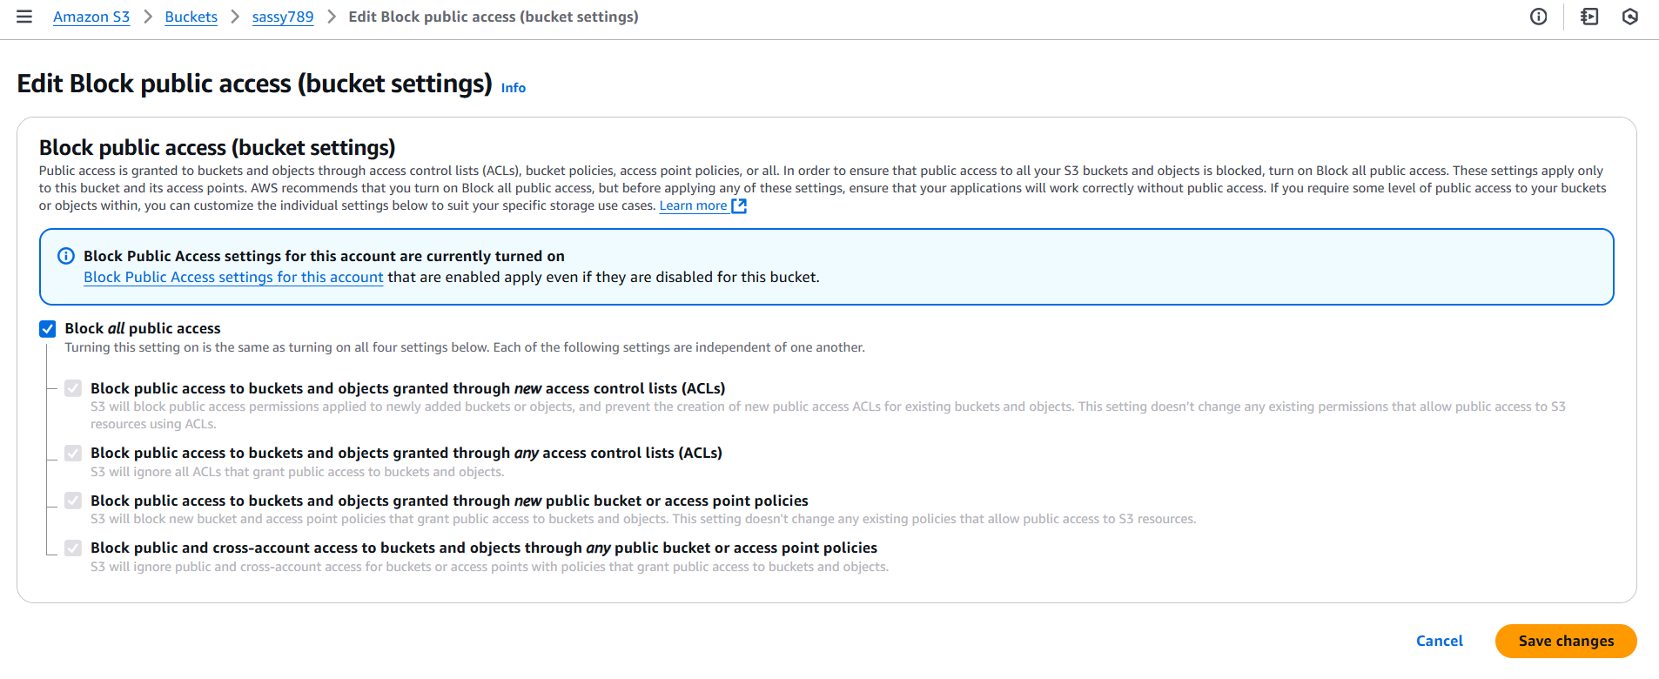

Step 8: Copy the Url in Copy URL option (S3)

Step 9: Paste the link in the new tab and you can see the uploaded file.

I have uploaded an image::



**Outcome**

* Successfully creating a cloud storage bucket.
* Uploading and downloading files from the bucket.
* Configuring access control for public or private storage.
* Understanding best practices for managing cloud storage securely.